# WEB ENGINEERING

**Course Instructor: Razi Ahmad Date: 12-01-2018**

# LAB 12

**JSPSERVLETS and Cookies**

**Note:**

* Student collaboration is not allowed.
* Copying from or looking at solutions from other sources is strictly prohibited.
* Violations will not be excused and may result in an F in the course.
* Stay honest.

Task 1:

Write a program that is going to perform Login Validation. Design an HTML Page that will get username and password from the user. Write a servlet class that will validate password and username and will forward to Welcome Servlet. The Welcome Servlet will display welcome message to the user by displaying his name too. If the password or username is incorrect it will display an error message. Use hardcoded information for username and password.

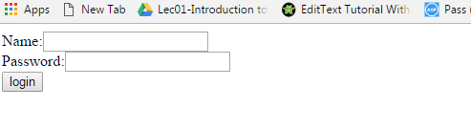

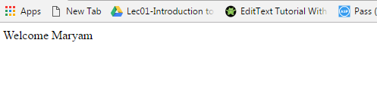

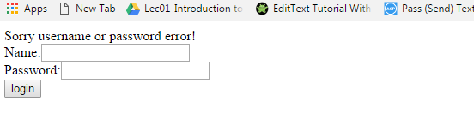

Task 2:

Write a program that is going to perform Login Validation through Cookies. Design an HTML Page that will get username and password from the user.

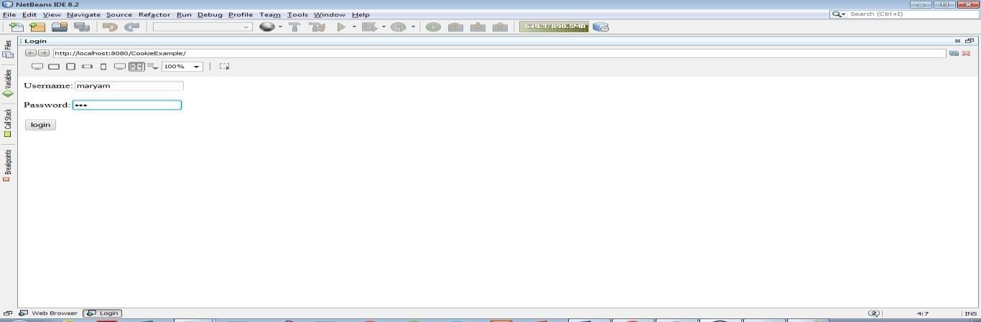

Write a servlet class that will validate password and username and will create a cookie. Handle all the validations properly.

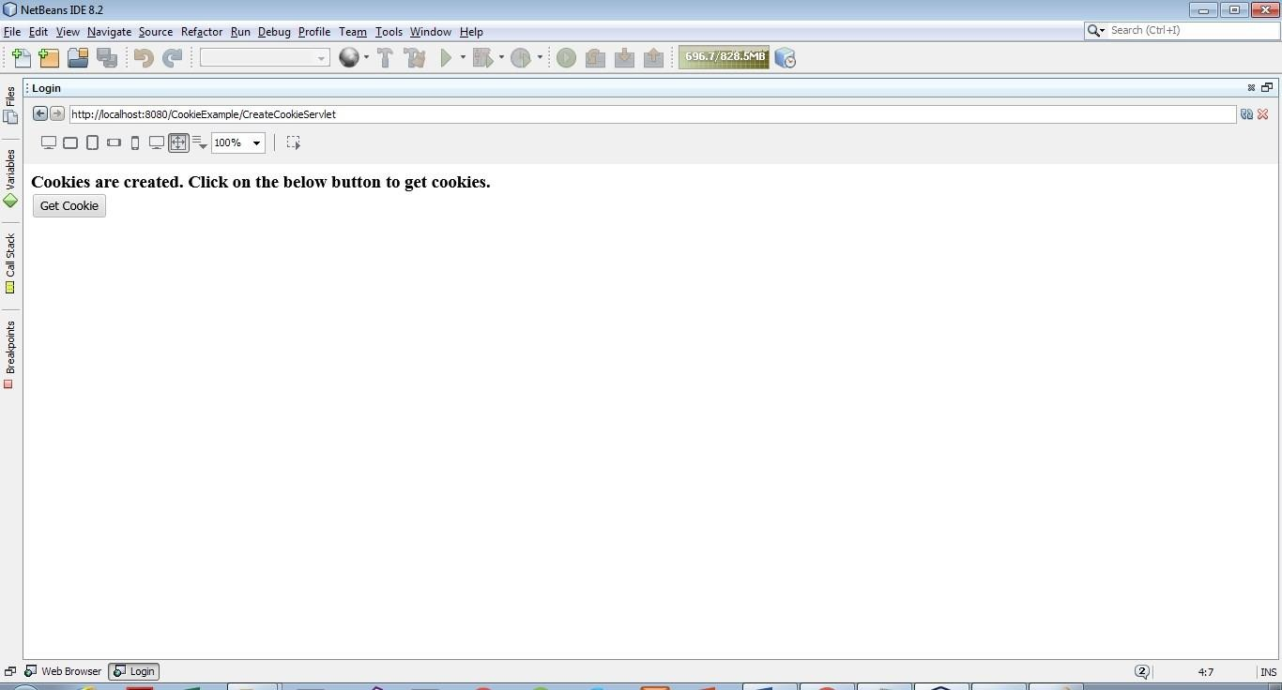

When “Get Cookies” button is clicked it should get the username and password through a cookie and display it on screen.

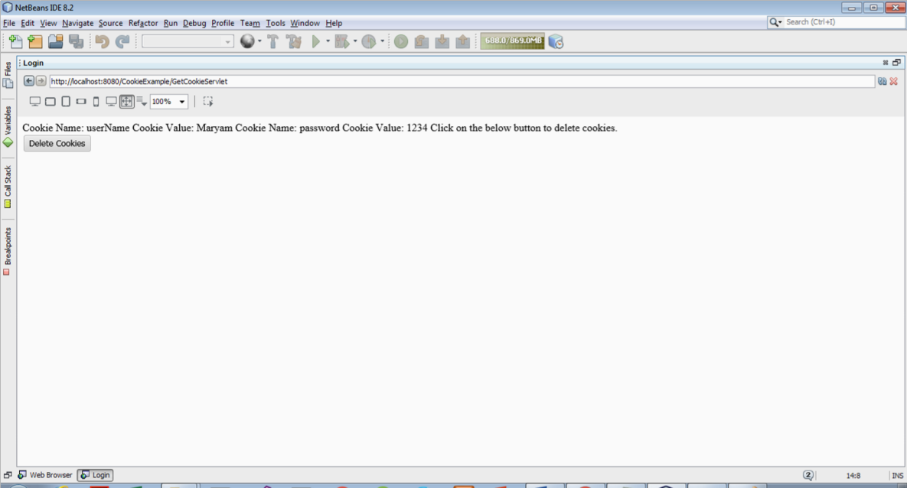

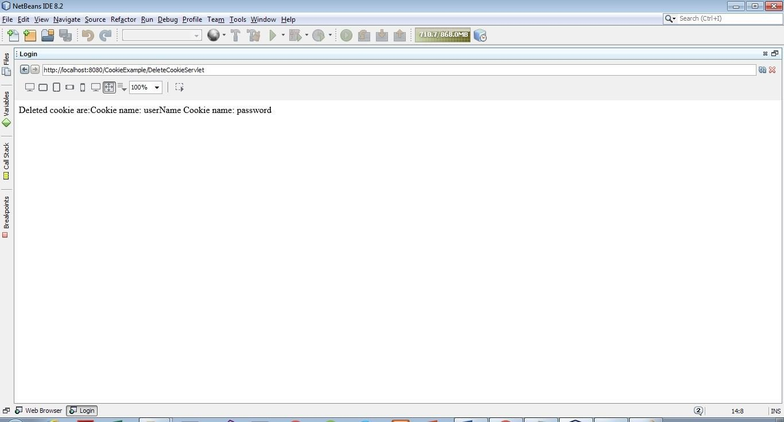On the click of “Delete Cookie” button it should remove the username and password saved through cookies.